CS691 – Computer Science, Fall 2022

Pace University



SYSTEM TEST PLAN

Reviewer

Authors:

1.Kaushal Dobaariya

2.Vaibhav Babariya

3.Vignan Kasam

Project Manager: Sanjeev Kumar

Date: 04/28/23

**Table of Contents**

INTRODUCTION 3

TESTING SCOPE 3

TESTING OBJECTIVES 3

Features to be Tested 4

Features not to be Tested 4

TEST PROCESS DEFINITION 5

Test Process Phases and Tasks 5

Deliverables 6

APPROACH TO SYSTEM TESTING 6

Approach to Functional Testing 6

ENTRY/EXIT CRITERIA 6

Entry Criteria 6

Exit Criteria 7

ENVIRONMENTAL NEEDS 7

ROLES AND RESPONSIBILITIES 8

TEST CYCLES AND SCHEDULE 8

RISKS AND CONTINGENCIES 9

# INTRODUCTION

This document explains the System Test Plan, which enables the "Reviewer" project stakeholders to have a shared knowledge of the objectives, approach, and scope of the system testing. The document also describes the features that will be tested, the testing entry and exit criteria, the resources and tasks, and the testing timeline.

# 

# TESTING SCOPE

The functional scope and technical scope are two views that make up the testing scope.

The User Experience, User Registration/Login, and Customer Support modules of the "Reviewer" system are included in the functional scope.

The technical scope includes the following architectural components:

* Web browser
* Application server
* Database server
* Content server

# 

# 

# TESTING OBJECTIVES

The primary focus of this System Test Plan is functional testing with the objective to evaluate the system implementation stability. The non-functional testing requires some special tooling to monitor performance characteristics, which is not available on this project.

The basis for developing functional tests and evaluating the system functionality includes the following sources:

* Business Requirements Document (BRD)
* User Stories (functional requirements)
* Requirements Composition Table (supplementary requirements)

## 

## Features to be Tested

This section lists all core features that will be tested grouped by the application modules below.

User Experience

* able to create account
  + To test whether the user is successfully able to create account and input the data as field validation.
* able to sign in
  + To test whether the user is successfully able to sign into the application
* able to modify account
  + To test whether a user can successfully change the data’s what that want in their profile.
* able to provide customer support
  + Test whether a customer are able to contact the Reviewer team to get help regarding application

User Register/Login

* User Registration
  + Test whether a user can register/create account.
* User Login
  + Test whether a user can login once they have registered.
* customer support
  + Test whether a user can contact to reviewer company for help.

Besides the core features in the scope of testing, the function testing also will cover crosscutting concerns that are applicable to the context of the individual core features (refer to the RCT).

## 

## Features not to be Tested

As mentioned above, system performance will not be tested for the lack of required tools. Also, usability and security will not be tested as well.

# 

# TEST PROCESS DEFINITION

## Test Process Phases and Tasks

The test process consists of five phases, which include test planning, design, preparation, execution, and reporting. Each phase has a few tasks as defined below:

* Test Planning
  + Define scope and objectives of testing
  + Define roles and responsibilities
  + Define testing approach
* Test Design
  + Identify test ideas, define an approach to designing test cases
  + Develop test case specifications
  + Measure test coverage
  + Determine requirements for test data
* Test Preparation
  + Setup a test environment
  + Provision test data
  + Install the software in the test environment
* Test Execution
  + Execute all test cases
  + Find and report software defects
  + Evaluate the system stability
  + Validate all target features
* Test Reporting
  + Summarize and report the test execution results
  + Report defect metrics
  + Evaluate the test exit criteria
  + Create a test completion report, submit for stakeholder approval
  + Obtain stakeholder signoff on system testing

## 

## Deliverables

On this project, the test process deliverables include:

* System Test Plan document
* Test Design specifications
* Test Case specifications
* Software Defects
* Test Execution Logs
* Test Completion Report

# APPROACH TO SYSTEM TESTING

## Approach to Functional Testing

The general way to deal with utilitarian testing will be founded on the Black-box strategy:

* Experiments will be planned to utilize some proper discovery procedures, for example, limit esteem investigation, identical class dividing, cause-impact diagramming, choice tables, and state-change testing, where relevant.
* From the user's point of view and based on formal test case specifications, manual test execution will be carried out.

Test execution logs will contain information about the test execution's outcomes.

# ENTRY/EXIT CRITERIA

This part characterizes both Entry and Exit Criteria for test execution and is expected to lay out a typical comprehension about the circumstances when the test execution can begin and when it can stop.

## Entry Criteria

The following items make up the test's Entry Criteria:

* The application build is made and put into use in the test environment.
* The system test plan has been created and approved
* The test environment is ready for testing.
* The test case specifications and test designs have been completed.

## Exit Criteria

The test Leave Models incorporate the accompanying things:

* Test cases cover every requirement that falls within the scope of testing.
* All of the test cases have been run.
* There are no remaining Critical or High-Severity defects.
* Workarounds exist for open defects of medium and low severity.
* The test summary report is made and put out.

# ENVIRONMENTAL NEEDS

To begin testing, the Test Environment ought to be accessible. It includes internet browsers (Chrome, Firefox, Internet Explorer, and Safari) for accessing the application as well as a laptop with a virtual machine running the web server and database. The engineering of the test climate is displayed underneath.

**Reviewer**

Type: Application Architecture

View: Process View

Style: Client-server N-tier Architecture Pattern.

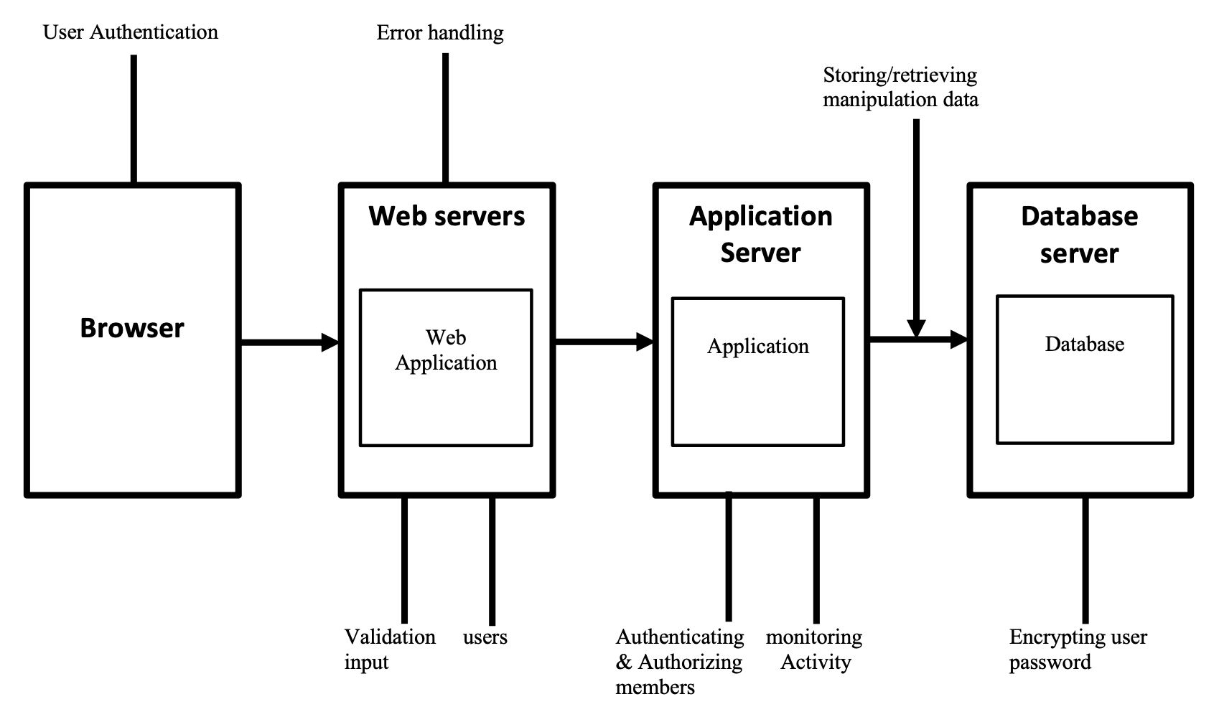

# ROLES AND RESPONSIBILITIES

The project team has seven members that are assigned various project roles including Project Manager, Product Owner, Lead Business Analyst, Lead Developer, DBA, Lead QA Analyst. Their responsibilities are defined in the table below.

| **Project Role** | **Role Responsibilities** |
| --- | --- |
| Project Manager | Reviewing and approving the System Test Plan, test design specifications.  Managing the test environment preparation.  Tracking the testing schedule and results. |
| Lead QA Analyst | Designing a test plan, establishing a test repository, developing test case specifications, executing testing and reporting defects. |
| Product Owner | Contributing to the test plan and test case specifications. Reviewing test results. |
| Lead Business Analyst | Contributing to the test plan and test case specifications. Reviewing test results. |
| Lead Developer | Establishing and maintaining the test environment, assisting a Lead QA Analyst throughout the testing process. |
| DBA | Assisting the Lead Developer in establishing and maintaining the test environment. |

# 

# TEST CYCLES AND SCHEDULE

The system test execution will be conducted as three test cycles that are aligned with three application modules as follows:

Cycle 1. User Experience I (Sign up/Sign in)

* This cycle concentrates on testing the first part with create account and sign in

Cycle 2. User Experience II (modify account)

* This cycle concentrates on testing the second part of user experience by modify account

Cycle 3. user experience III (customer support)

* This cycle concentrates on testing the third part customer support

See the schedule of the test execution cycles in the project plan.

# RISKS AND CONTINGENCIES

The risks and contingencies that might have occurred during the system testing are highlighted in this section.

* Restricted testing asset might bring about a postponement.
* Any alterations to the scope objectives may result in additional work or a delay.
* It takes longer to fix a large number of defects and complete testing.
* The progress of the testing may be harmed if members of the team don't work together.